CFCD - Jaffna
Case Study
DS/Tellipalai:
“The resettlement task is heavy and there are many families waiting to get resettled. There are not many agencies to provide assistance and support to those who want to get resettled, and the government has very limited capacity in this aspect. Thus, when the demand for resettlement increased British High Commission through UNDP came to our rescue and the process has been very successfully launched to benefit many deserving families. It is a fact that without the meaningful and heavy inputs of BHC through UNDP DS/Tellipalai office would have found d it extremely challenging to satisfy the emerging needs of the many families that came for resettlement. Thus, we have to be grateful to BHC and UNDP in the endeavor to have taken the trouble and assist the much-needed resettlement in our DS Division” said Mr.S. Sivasri, Divisional Secretary, Tellipalai sat a monthly DCC meeting held at the DS Office recently.
Agriculture:
The lands allowed for resettlement were uninhabited for over 3 decades and appeared as thick jungles. Many could not identify their property leave alone the easy access. Those who knew the history of the land have either gone outside or dead during the conflict. The situation became miserable for many. Thus, the resettlement posed great challenges at the beginning, However, steps were gradually taken to make easy access to the area through jungle clearance and providing assistance in the surveying and marking of lands by the government. The timely intervention of BHC through UNDP made it easy for the families to get confidence on the process and make positive efforts to resettle in own lands. The provision of temporary shelters / semi-permanent structures took place on the one side while the LH assistance of BHC/UNDP made it feasible for them to commence cultivation and earn an income in parallel.
The beneficiaries had little resources on their own to invest on anything. However, the inputs provided through the projects of BHC/UNDP facilitated them to continue the cultivation the second time but on an increased capacity which guaranteed added earning from the fertile land. The progress made the others waiting for resettlement to come forward and occupy their territories on the longer run. Thus, sustainable resettlement got induced and the process is continuing until now with most of the potential beneficiaries come back to live in their traditional lands.
Enterprises:
The returnee families faced immense hardships to earn any income although there were many skilled persons who had no financial support to invest. The projects initiated and funded by BHC with UNDP made it possible to sort out the difficulties and make the potential persons thrive in identified professions and make them earn reasonable and steady income from the resettled environment. Some of the very successful entrepreneurs were able to provide employment opportunities to a couple of other young persons from the community. This became quite successful and the youths continue to work more to expand their business ventures. At the beginning the youths had to borrow their tools and equipment which resulted in reduced earning but with the support of BHC/UNDP they got new items making their profit much more.

Overall - improvement:
The following is a tentative table to indicate the overall improvement of the status of the beneficiaries with the intervention of the SDR projects funded by British High Commission -BHC through UNDP:
Sector | Tent. of improvement
Agriculture | From Rs 10,000 to >Rs 30,000
Enterprises | From Rs 10,000 to >Rs 40,000
Livestock | From Rs 5,000 to >Rs 20,000

Some example
“It has been a nightmare to spend time without any income when being physically handicapped. But the troubles gradually got reduced with the required assistance coming from UNDP through CFCD for the concrete mixture” was the immediate response of Pushparajah Anith (29) who is a PWD with his spinal cord problems. He is able to employ 2 youths on a permanent basis and earn as much as Rs 80,000 as his monthly profit. He is from Thenmylai and is a beneficiary on SSRS and later in SDR for scaling up business.
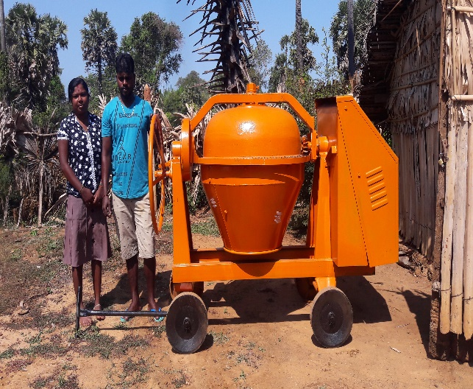
Pushparajah Anith- Concrete Mixture
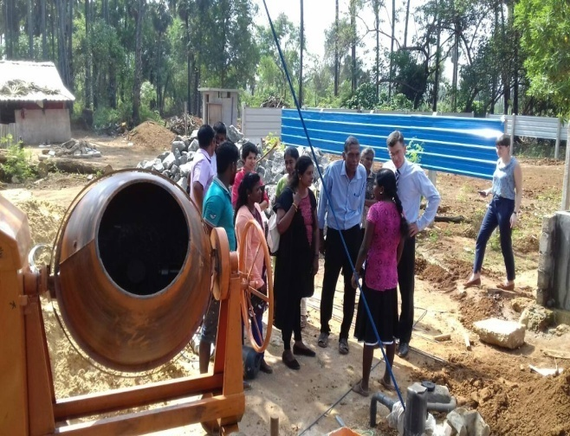

R. Mercy (35) a WHH with 2 children of Thyiddy East was involved in making handicrafts items on a small scale while in a displaced state and could make out a meagre income barely sufficient to meet her home needs. After the resettlement she could not even continue the same due to lack of proper space. When she approached CFCD her case was analysed and was provided partial support to construct a temporary shed from UNDP funds to commence the handicrafts production. “The timely input paved way for me to grow up quite fast. There are two women working fulltime to complete the vast orders. In addition, I could provide training to 2 young girls in making the handicrafts items. Thanks to UNDP which facilitated me to expand the business now. I have a very solid market in Vanni as well as Jaffna” Mercy says very proudly.
Sajeetha Banu is a very young lady from Kovilkudiyiruppu, Chavakachcheri living with her husband and 2 children. She is a Muslim by birth and got displaced from Chavakachcheri in 1990 and stayed in a welfare camp in Puttalam. She was resettled in 2002 with her parents and sister’s family. A house was provided by the Mosque for the 3 families to live together. Her husband didn’t support them, and they managed with her father’s income. She with her sister started to stich clothes and earned LKR 10,000 per month using an old machine. When she became the direct beneficiary of CFCD her husband also joined and started to support her in wholesale procurement. Her monthly income was over LKR 40,000.” I am very thankful to CFCD and UNDP for the timely support without any discrimination and I can stand in my own feet. My children are getting good education and other facilities. In the meantime, with my contribution I can support my parents as well” says Sajeetha Banu happily.
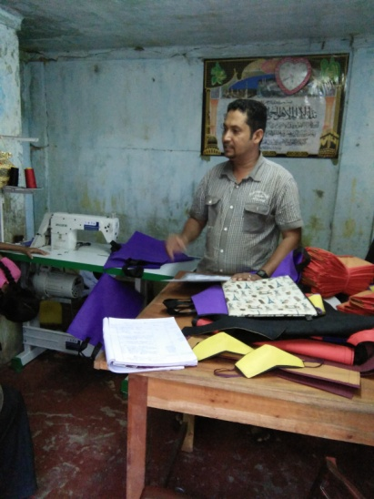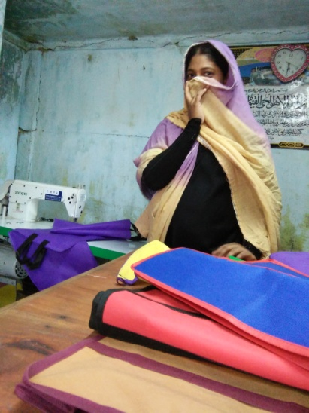
Sajeetha Banu- Tailor
These are positive examples of the impact created by the intervention of British High Commission (BHC) through Support to Durable Resettlement in Sri Lanka - SDR Phases I & II
The projects were designed during the early part of resettlement in Jaffna district, and it demonstrates a commitment to address the need of the returnee people. The interventions are designed to inject much-needed livelihood inputs and support the state’s provision of sustainable solution for returnee population. The projects provide sustainable income that exceeds the rural norms in Northern part of Sri Lanka for semi-skilled labour and have the potential to transform household and village economies. The war affected communities to return to their original localities and resume their lives on a sustainable basis is a massive challenge. This requires concerted efforts, coordination and resources of many actors, including governmental and non-governmental agencies and development partners. Accordingly, the resettlement projects were designed to support the durable resettlement of communities and build confidence and trust in the reconciliation process.

Programme Manager
CFCD, Jaffna / 7 June 2021

Sinnavan Ithayakumar – Agriculture

Sinnavan Ithayakumar is a 45 aged farmer. His family was lost the normal life got displaced during the mass exodus in October 1990. His family proceeded to Vanni and settled. While they were returning from Vanni , their land was captured by the military forces. Ithakakumar’s family got settled in Alady welfare center. After the release of land in Tellipalai by GoSL, he resettled in 2015.
GoSL supported him through the provision of 2 larcham of land with permanent shelter. His family was doing agriculture heredity by heredity, so Ithayakumar stared agriculture at first in the 20 larchams of land. SDR project supported by UNDP-BHC has given opportunity to encourage agriculture livelihood support.
CFCD distributed wooden body for land master under this project. Currently he leased additional 25 larchams of land and planted onion, chilly, manioc, brinjal, tomato, long beans and kurakkan. Ithayakumar harvested 45 anther onion and earned considerable amount. He is better utilizing land master for loading his products to markets where he obtains high demand for the vegetables. He happily says “my monthly income has increased as 45,000 -50,000 a month and my family is obtaining sustainable income to meet all the requirements”.

Strengthening Community based Organization
Community Based Organizations are the local existing governing bodies in the village. They are responsible to develop the village, utilize local resources and structure the leadership. The functions of the CBOs include the strengthening of the leadership and facilitate to carry out tasks independently. There are a few personnel in the village who try to dominate the total functions of the CBO.
The assessment was done by the CFCD officials using the following methodologies:
- Questionnaires
- Key informant interviews
- FGDs and
- Stakeholder Consultations.
Primary data collection began with Questionnaires. A total of 42 Assessments were conducted by the CFCD field team. This assessment took place in order to assess the views of key government officials, civil society actors, development workers, elected representatives and community leaders, specifically with regard to livelihood shifts and community dynamics in the relevant areas.
Vesky women Rural development Society (WRDS) in Reclamation East is such a community-based organization registered in 2017. Through the intervention of this project the society established well including 12 committee members and 130 members.
The potential for value addition training was motivated by CFCD team and re organized the women group who were already obtained start up training on leather bags production and footwear. 13 days value addition training provided by a master trainer of Industrial Development Board, Jaffna. The women took part in the training actively and presented a final day mini exhibition. The DS of Jaffna appreciated the activities and promised to provide a sales unit. Three numbers of industrial machines provided by this project and the production of leather bags, foot wear , OBM cover and other demandable products.

Velumylum ASOK, Fishermen, Salli, Trincomalee

In 2021, the Support to Durable Resettlement (SDR) project, a three-year project, funded by the Government of the United Kingdom (UK) and supported by the United Nations Development Programme (UNDP) in Sri Lanka, Implementation partner KAVIYA –SDWC, contributed to providing newly resettling communities with durable resettlement opportunities including access to essential basic services, sustainable livelihoods and income generation opportunities in the Batticaloa and Trincomalee. Batticaloa, Kilinochchi, Mullaitivu, and Trincomalee Districts. Under the project, a broad-based needs assessment was also conducted to understand economic growth and sustainable development options for Internally Displaced Persons (IDPs), Indian Returnees persons (IRP) and refugee returnee communities in the Eastern Province.
During this assessment process, Ashoke requested to support his fishing. As a beneficiary, Asoke was given an outboard engine, and fishing nets to help him increase his income .The family lives in Salli, some thirty minutes away from Trincomalee .
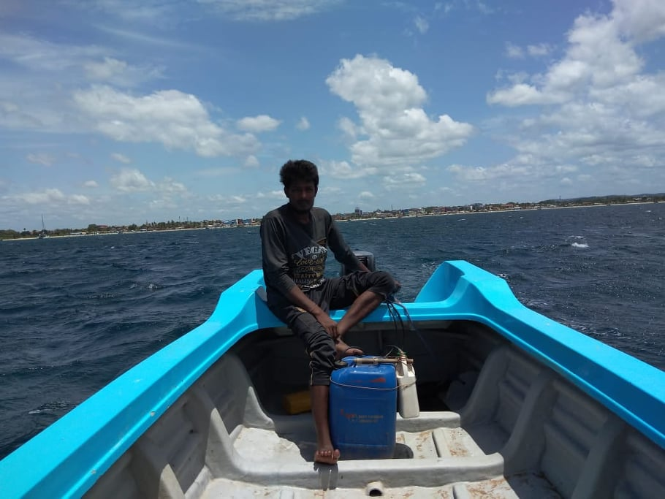
Asoke and his family are relatively recent returnees. “I have Worked more than 6 years as a labour ,”he says describing how they experienced multiple displacements. “Now we feel so privileged and proud to have a own Boat .”
Around 40 families had boats of their own but, like Asoke, the majority needed help to purchase outboard engines. 55 Indian returnees fishing families were given fishing gears. For the fishermen though, the most critical aspect has been the creation of two access ways into the ocean, which were designed and built with through the support of UNDP.
The routes cut through thick beds rock, to give them a clear passage to the ocean beyond. The rocks that remains has created a small, protected harbor for their boats
“Our outboard motors are very expensive,” says, Ashoke explaining that a little damage could cost as much Rs.35,000 in repairs. Before the new passages were opened, they could not even enter the sea between January and April, when the ocean tended to be particularly rough. “Now we can go in year-around,” adds Asoke, who appreciates the thoughtful design.
There are even stairs going up the steep incline of the beach, so that the fisherman can haul up heavy catches without tearing their nets. In addition to these, UNDP also supported the establishment of an auction center for the fisherman and a ‘repose’ room where they can rest in between expeditions. Taken together, these measures have ensured that after years of struggling to survive, fishing families can now count on their livelihoods.

Ravichanthiran SINTHUJAH, YED, Cement products entrepreneur, Vaharai, Batticaloa

Ravichanthiran Sinthujah is another young person who was supported by the Durable resettlement Programm. Bent over in quiet concentration, the young Sinthujah mixes cement, sand and gravel in a tin shed next to her home. Beside her stands the concrete block making machine, ready to take in the mixture in a few minutes and turn it into neat concrete blocks. The day has just begun and there are already some hundred blocks baking in the sun… somewhere not too far away, a well is to be built and it awaits the arrival of her concrete blocks.

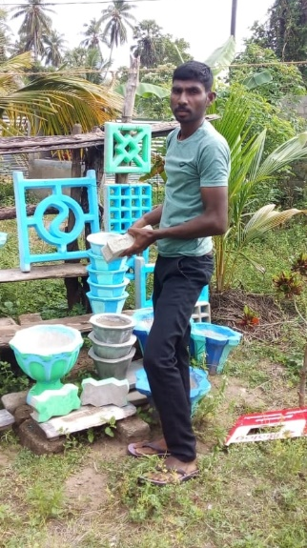
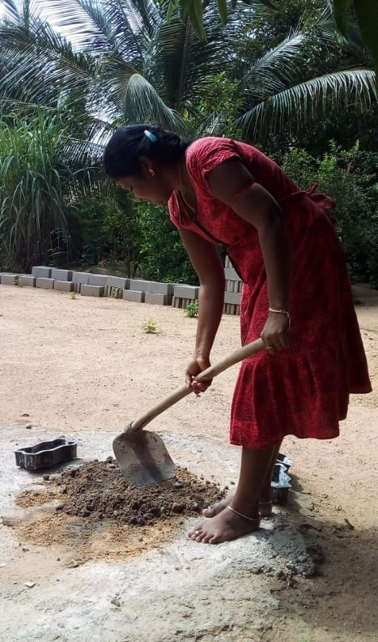
For all this process his husband Ravichanthiran is supporting her. Before the program she has only block making machine, through the program UNDP supported her to purchase the axis to make the cement related things. Now she is very happy to doing his work with her husband.
“Growing up, I had seen my husband making blocks at work-sheds of other people for daily wages. It was something I was familiar with, and thanks to the confidence instilled in me by the five-day workshop conducted by UNDP, as a women I was ready to embark on this new home business”.

It has been six months into Sinthujah entrepreneurship; today she employs two assistants and supplies concrete blocks, cement flower vase, pillars, garden beautification items made by cement, and for the construction of houses, wells, toilets and other buildings in the area. A cement bag costing Rs. 1600 makes up to 80 concrete blocks, which are then sold at Rs. 32 each. With this income, Sinthujah ensures her cost of living and supporting for her husband to manage the household expenses.
“This is the first time the young women entrepreneur has to think differently to carry out the cement work in our area .and this is the good beginning for the women’s entrepreneurs who has to start the new journey of business…she said”

Dinesh YED, Automobile Mechanic Morawewa, Trincomalee
Dinesh is an youth entrepreneur who lived in Morawewa division, Trincomalee district. Not long ago, Dinesh was a laborer at a repair-shed in3rd mile post at Trincomalee , where he initially picked up his interest for auto mechanics. His hard work and fascination with motorbikes later earned him a slot at the Hero Motorcycle Showroom in the area. Recognizing his enthusiasm, the dealership sent him for training in Auto –tag engineering
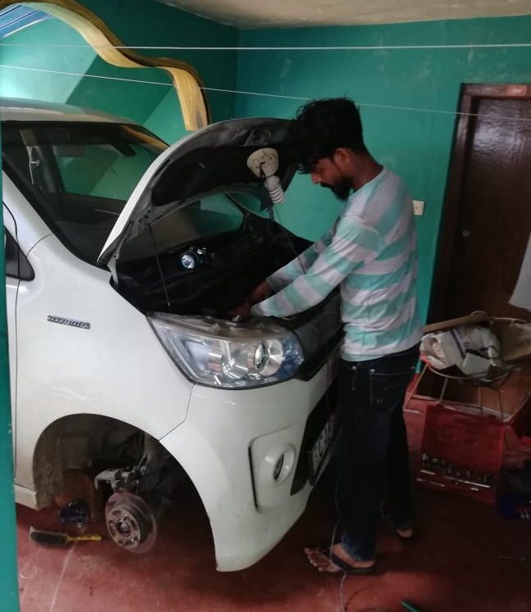
With the experienced, when Dinesh was looking for a break-through in his career is when he encountered personnel from UNDP. As an area with resettled families post-conflict, Morawewa was one of the villages under UNDP’s ‘Support to Durable Resettlement in Sri Lanka’ project funded by the Government of the United Kingdom. The project consisted of youth empowerment among Indian returnees areas, with the objective of addressing the problem of skills shortage. YED focused on inculcating employable skills and business development knowledge in its participants.
Being part of YED, Dinesh not only learned business planning and received an introduction to customer relationship management, but also secured a bank loan with lower interest rates, facilitated by the project. He was also provided with a compressor, a high-pressure washer, and mechanic tools needed to set up new repair shop.
“I had the technical knowledge, but had no clue about starting up a business or managing it. The training I received at the YED programme equipped me to not only set up my own bike shop, but also taught me how to acquire customers and retain them,” said Dinesh when asked about his newest venture.
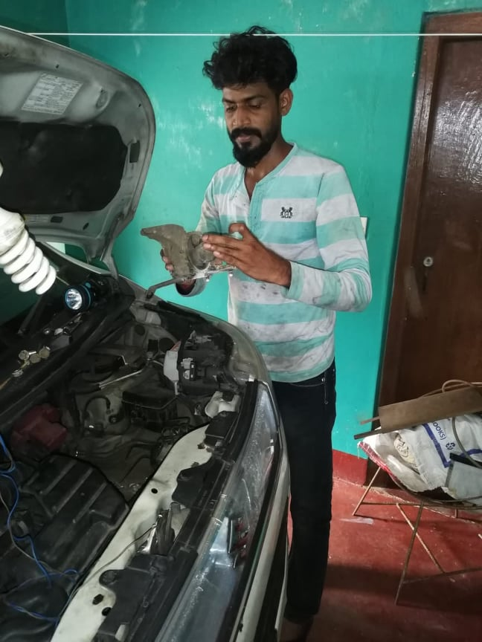
“I have also learned not to wait for business to come to me; I want to be known in this area as someone that can be called upon in an automobile emergency situation,” he concluded.
‘Support to Durable Resettlement in Sri Lanka’ is a project implemented by the Government of Sri Lanka and the United Nations Development Programme with funding from the Government of the United Kingdom. This program over 70 young people in Trincomalee and Batticaloa have been able to enhance their skills to start their entrepreneurship journey.

